Case Study 1: HealthifyMe

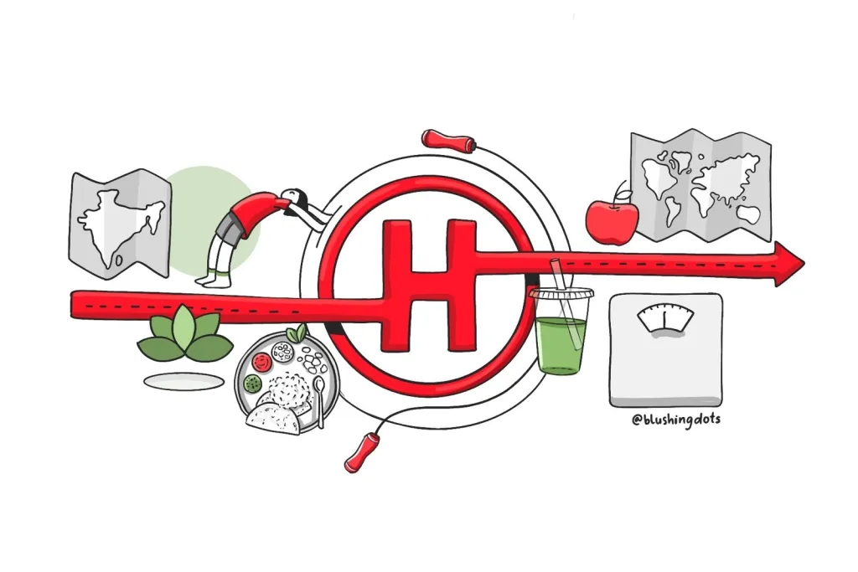

*Optimizing Customer Engagement and Conversion Rates*

HealthifyMe is a leading health and wellness company that helps people worldwide with personalized diet and fitness plans. They’re all about making healthy living easy, especially for folks in India and Non-Resident Indians (NRIs). Their main way of earning is by offering personalized plans designed for different health needs.

**Business Problem**

HealthifyMe is really excited about making their sales process better! They want to make customers more involved, get more people to sign up and of course, make more money. The big plan is to make it easier for users to book and have a great time doing it.

**Dataset Overview**

Fortunately, HealthifyMe possesses a valuable asset: a dataset with information about free user bookings over a two-month period. This data includes details like:

* **Funnel types:** Were these leads generated through the chat bot or free trial?
* **Lead types:** Did they have a medical condition? Were they Indian or NRI?
* **Coach performance:** How effective were different coaches at converting customers? (A being the best and D being the worst)
* **Booking outcomes:** Did the consultation ultimately lead to a subscription purchase?

**Objective**

We want to take a close look at the data we already have, figure out the trends that lead to successful bookings and see how often people end up booking. We’ll also look at conversion rates to see how many inquiries turn into confirmed subscriptions. Let’s dig into the information and see what makes our bookings work well!

**Case Study Roadmap**

Here’s the framework I’ve created for conducting this case study.

1. **Research:**Understand the company’s nature and objectives to determine how the analysis can benefit them.
2. **Business Problem:**Identify a specific business problem that the company is facing and that data analysis can help solve.
3. **Scenario Setup:**Construct a hypothetical situation or scenario that aligns with the chosen business problem for analysis.
4. **Ask Questions:**Develop relevant questions based on the chosen business problem and scenario to guide the analysis.
5. **How to Proceed:**Outline a preliminary plan or blueprint for the analysis, detailing the steps to be taken for success.
6. **Select the Right Tools:**Choose appropriate tools, such as Excel or SQL, needed for the analysis based on the outlined plan.
7. **Explore the Dataset:**Familiarize yourself with the basics of the dataset, gaining an understanding of its structure and content.
8. **Analysis:**Perform the analysis as per the plan, using the selected tools and addressing the questions formulated earlier.

# 

**Data Cleaning/Preprocessing**

1. Utilized the “Text to Columns” feature in Excel to separate values by a comma delimiter. This step was essential for organizing and isolating relevant information.
2. Identified and removed duplicate entries to ensure data integrity and avoid redundancy, contributing to a cleaner dataset.
3. Derived a new column, named “Payment,” from the “Payment Time” column. This column serves as an indicator of subscription status, with null values indicating no subscription purchase and timestamps indicating a subscription purchase.
4. Employed an IF statement to categorize subscription status efficiently. Specifically, used a logical test to check for null values in the “Payment Time” column. If null, assigned a value of 0 (indicating no subscription purchase); otherwise, assigned a value of 1 (indicating a subscription purchase).

**Data Exploration**

I always start the analysis with a peek into the raw data using simple SQL queries. By examining the unique values in essential columns, we lay the foundation for a comprehensive understanding of the dataset.

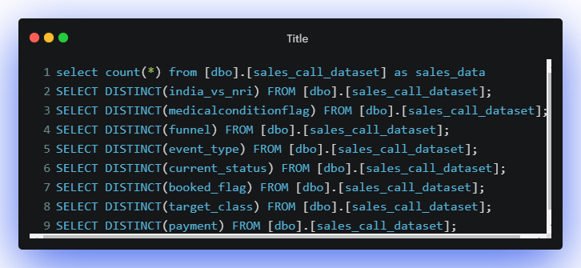

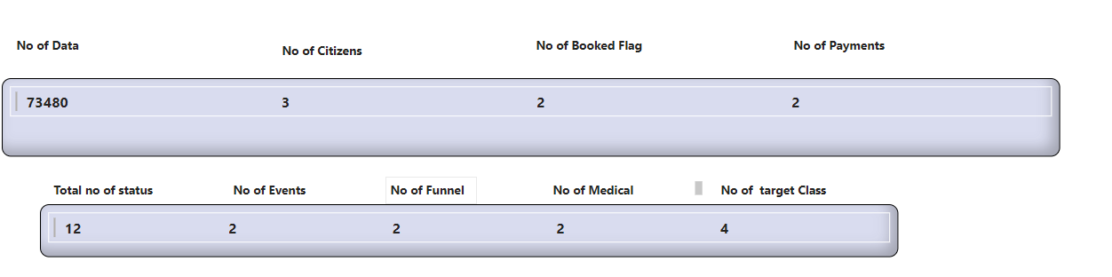

**Conversion Rate**

The conversion rate is the percentage of people who subscribe or sign up for a service out of the total number of people who visit or engage with a platform. It indicates how effective a platform is at turning visitors into paying subscribers.

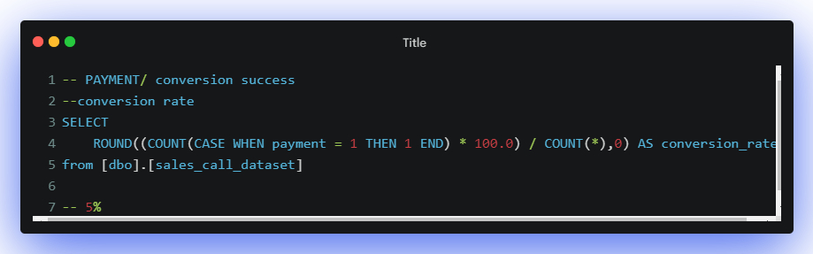

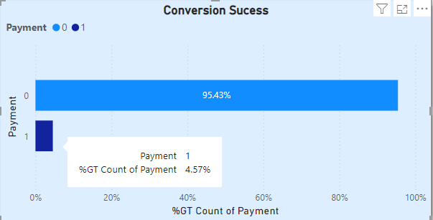

**Result:** The low conversion rate of **5%** indicates that only a small fraction of the total sales calls result in successful transactions.

**How successful bookings and conversion rate vary between Indian and NRI users?**

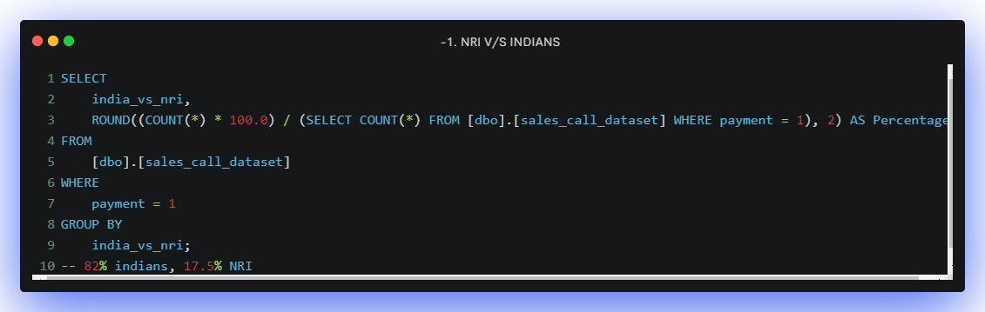

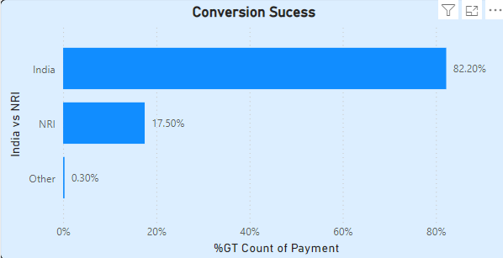

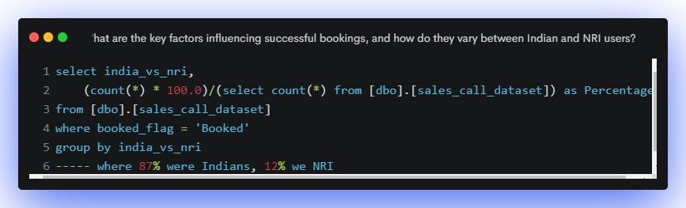

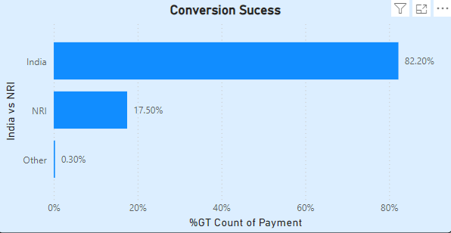

**Is there a relation between the presence of medical conditions, booking success and conversion rates?**

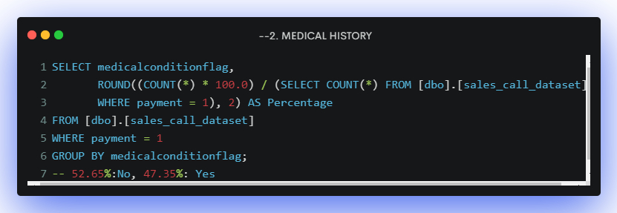

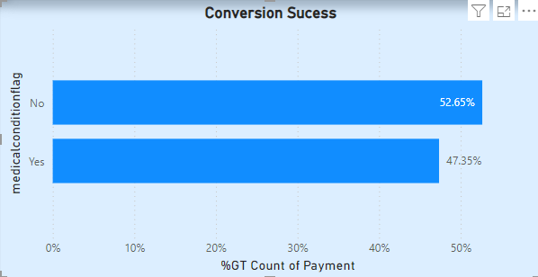

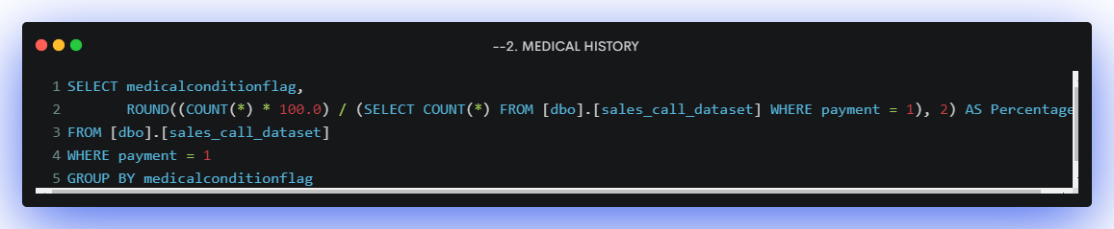

**Result:**Users without medical conditions exhibit higher success rates both in bookings (61%) and payments (52.65%).

**Can we identify patterns in the funnel stages that lead to higher bookings and higher conversion rates?**





**Result:**Free Trial (FT) users show a higher booking success rate at 52.6%, while Bot users have a higher payment success rate at 58%.

**Are there specific times or slots that result in higher booking success and higher conversion rates?**

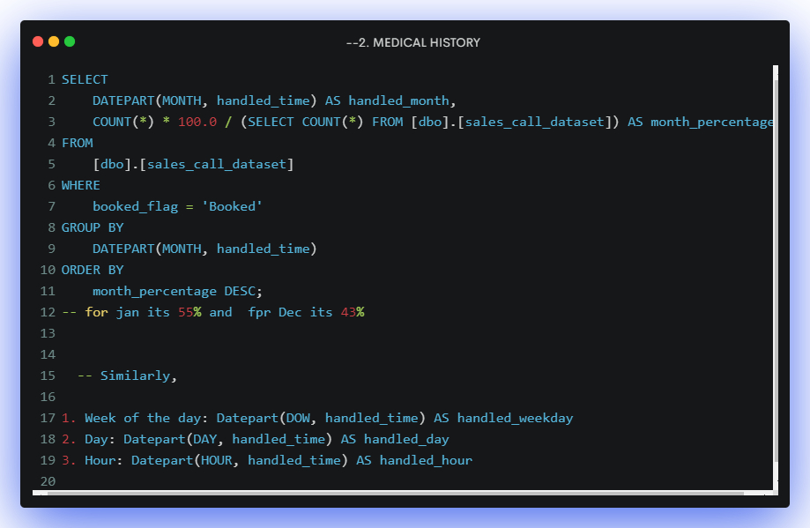

**Result:**Booking success rates are higher in January and December, particularly on Mondays and during the early days of the month. Similarly, conversion rates are higher in January and December, on Tuesdays, and during the early days of the month.

**What target class influenced higher successful bookings and conversion rates?**

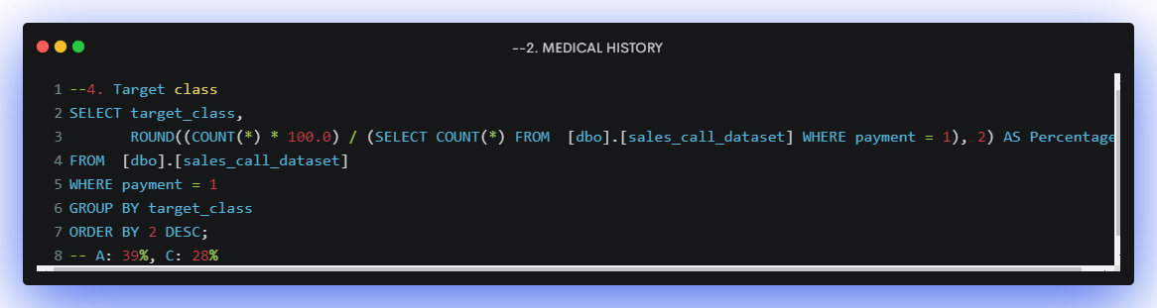

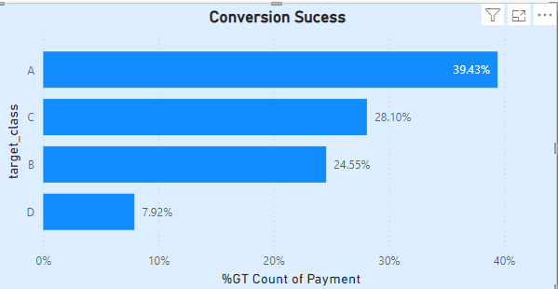

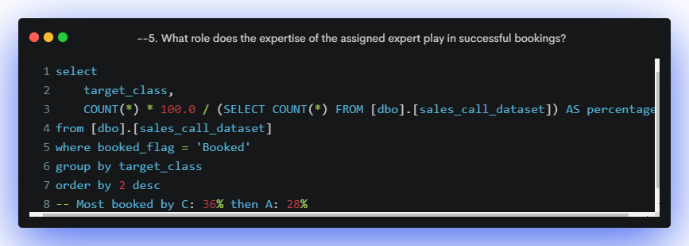

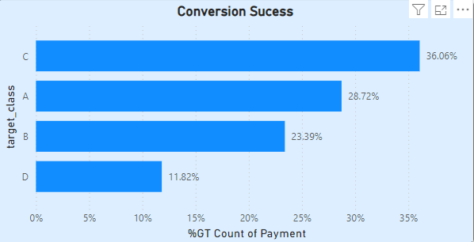

**Result:**Users assigned to experts in target class C achieve the highest booking success rate at 36%. Meanwhile, Class A has the highest payment success rate at 28%.

**Report/Key Insights**

**HealthifyMe Insights: Boosting Conversions**

5% Conversion Rate

**HIGHER CONVERSION RATES?**

* 82% Indians
* 17% NRI
* 58% BOT Users
* 41% Free Trial

**HIGHER BOOKING SUCCESS**

* BEST TIME TO MAKE A CALL: Morning 10AM-12PM, January and December
* 56% Free Trial
* 61% Healthy users
* 43% BOT Users
* 38% Medical challenges

**BETTER CONVERSION RATE**

* 53% Healthy users
* 47% Medical Challenges

**TARGET CLASS**

* In First week of Month: Monday & Saturday
* Highest Bookings: Class C (36%)
* Highest Conversion Rate: Class A (39%)

## Insights from the Text

### Conversion Rates

* Overall conversion rate is 5%.
* BOT users have a higher conversion rate (58%) compared to Indians (82%).
* Free trials lead to a significant conversion rate (41%).

### Booking Success

* Morning calls (10AM-12PM) and calls during January and December have higher success rates.
* Healthy users have a higher booking success rate (61%) compared to those with medical challenges (38%).

### Target Class

* Class C has the highest bookings (36%).
* Class A has the highest conversion rate (39%).

### Overall

The data suggests that focusing on BOT users, free trials, morning calls, and January-December period can potentially boost conversions. Additionally, targeting Class A for conversions and Class C for bookings could yield positive results.